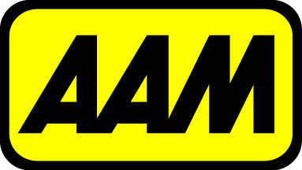
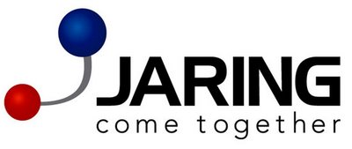
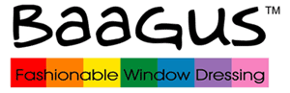















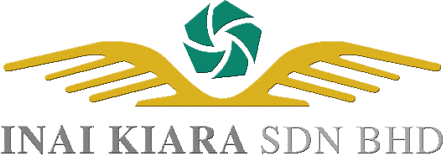

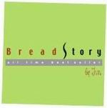









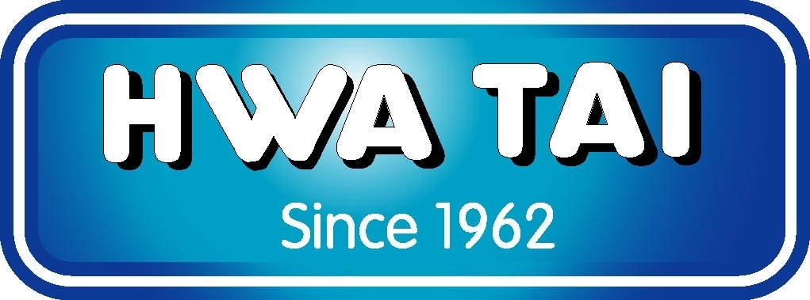


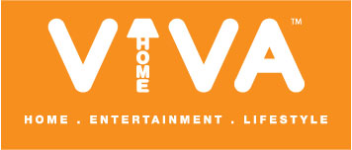


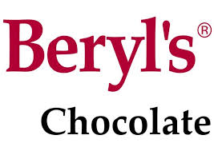


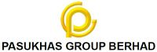
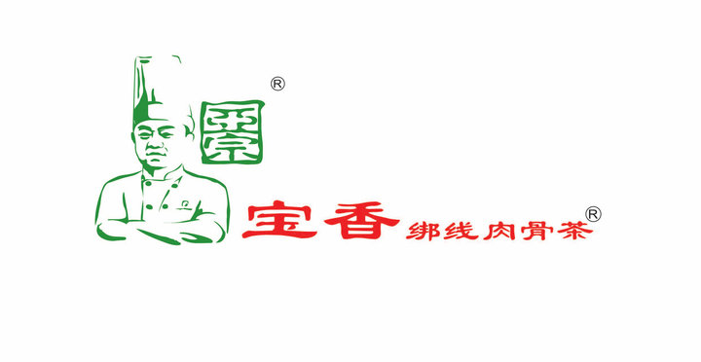







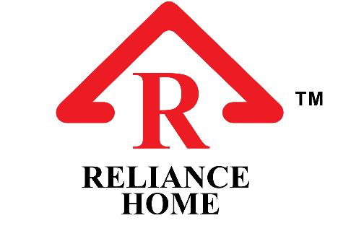




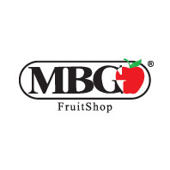

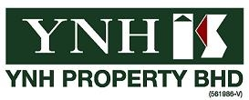
















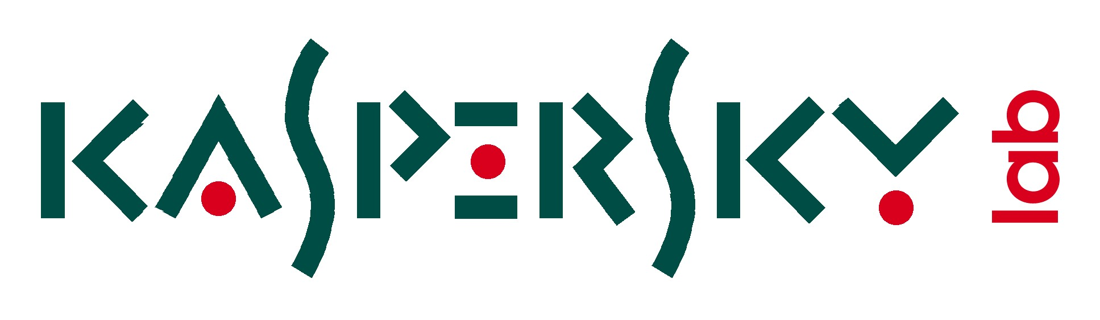



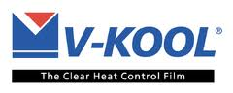

The following are a list of public listed & prominent companies that are using SQL Account.

Public-listed
-------------
Analabs Resources Berhad
CB INDUSTRIAL PRODUCT HOLDING BERHAD
CENTURY LOGISTICS HOLDINGS BERHAD
CME GROUP BERHAD
CNI ENTERPRISE (M) SDN BHD
COMPLETE LOGISTIC SERVICES BERHAD
Cypark Resources Berhad
DIGISTAR CORPORATION BHD
EcoFirst Berhad
EURO HOLDINGS BHD
Extol Corporation Berhad
FORMOSA PROSONIC ELECTRONICS BHD
HIL Industries Berhad
IJM Plantations Berhad
Lee Swee Kiat Holding Berhad
M3 Technologies (Asia) Berhad
Mechmar Corporation (M) Berhad
Pasukhas Berhad
Poly Tower Ventures Berhad
RESINTECH BERHAD
SUCCESS ELECTRONICS & TRANSFORMER MANUFACTURER SDN. BHD.
Tomei Berhad
United U-Li Corporation Berhad
Vitrox Corporation Berhad
Wawasan TKH Holdings Berhad
YNH PROPERTY BERHAD

Prominent Companies
-------------------
Automobile Association of Malaysia - AAM (Automobile membership services)
AK Koh Enterprise Sdn. Bhd. (A1 Bak Kut Teh & spices manufacturing)
Alphamatic Systems (IT Hardware distribution & BOSS Payroll software developer)
AQUAWALK SDN BHD (Aquaria KLCC)
Beryl's Chocolate & Confectionery (Chocolates & food proccessing)
Bread Story Sdn Bhd (Bakery retail chain)
CFB TRADING (KL) SDN BHD (Formerly Chin Foh Berhad)
EXERTAINMENT MALAYSIA SDN BHD (Celebrity Fitness chain)
GOLDEN DONUTS SDN BHD (Dunkin Donuts bakery retail chain)
Goodnite Enterprise (M) Sdn Bhd (Mattress manufacturer)
HONG KONG KIM GARY RESTAURANT (Restaurant chain)
Inai Kiara Sdn Bhd (Dredging, reclamation and marine-related construction)
Iskandar Investment Berhad (Developer of Iskandar Johor)
JARING COMMUNICATIONS SDN BHD (Internet Service Provider)
Kwasaland (Master developer of RRI land)
MBG FRUITS TRADING
MOEM HOLDINGS SDN BHD (Office equipment steel fabrication)
NSK HOLDING SDN BHD (Supermarket retail chain)
PONEY GARMENTS SDN BHD (Children clothings)
RAMPAI-NIAGA SDN BHD (The Body Shop, Cosmetic & toiletries retail)
Rockwills Trustee Berhad (Will writing & trust management)
Stormwater Management and Road Tunnel Sdn Bhd (SMART Tunnel)
UHY Accountancy, Tax, Audit , Advisory
VIVA MALL SDN BHD & Group of Companies (Developer & Mall Management)

