Sage 50 Data Import Guide – Draft (Modified: 08/01/2019)

**Connect to Sage 50 using ODBC/OLEDB**

**Section I: Allow Data Access from your Sge 50 Company**

1. Install Sage50 Peachtree.
2. Open Sage 50 and login into your company.
3. Select the Maintain > Users > Set Up Security.
4. Select **Data Access/Crystal Reports** tab on the User Security window.
5. Under Access From Outside Sage 50, select **With the following login information**, then press **Change**.  
   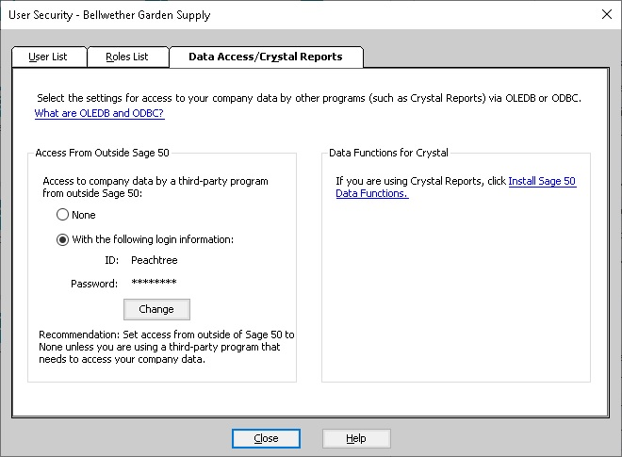
6. Enter a password and confirm it. **Note**: The password must be **exactly 7 characters** in length and contain at least one letter and one number.
7. Click **Close** to close the window and you will be ready to use and ODBC or OLE DB connection for read-only access to your company data.

**Section II: ODBC Connection**

1. Open the Start menu, type “ODBC32” and click the top result “ODBC Data Source (32-bit)” to launch the program

.

1. Click the Add button and then follow the steps below:

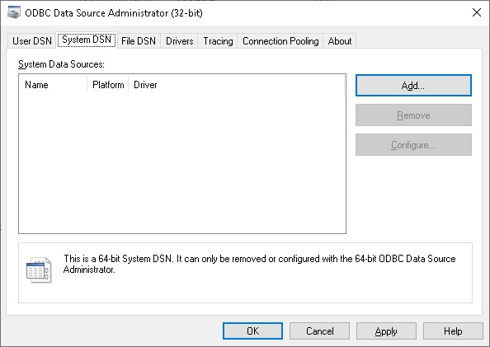

* 1. **Single user/Single computer environments:**
     + In the Create New Data Source window select **Pervasive ODBC Engine Interface** and click Finish.
     + 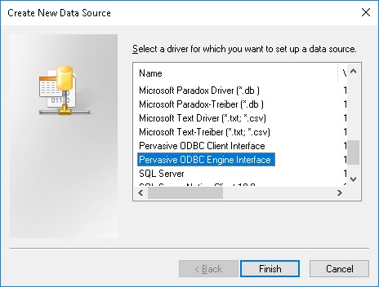
     + Once the Pervasive ODBC Engine DSN Setup window appears, enter the **Data Source Name** as “KP” and select one **Database Name** from the drop-down list. Click **OK**.

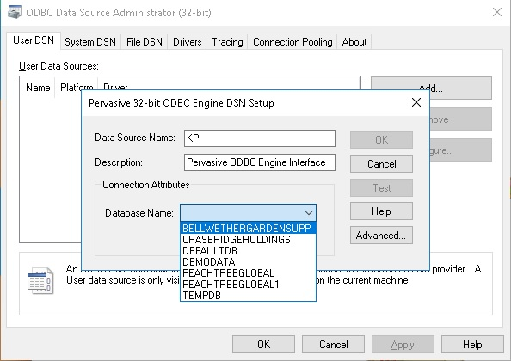

* + - The Data Source Name should now appear in the User Data Sources List. Select **OK**.

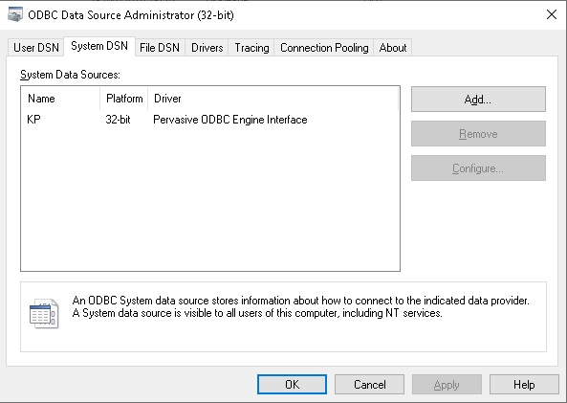

**Import Sage 50 Master Data to SQL Account**

**Note**: Tested only on Single user/Single computer environments

Execution steps:

1. Select File > Import > Sage 50 on the main navigation window.
2. Select the **ODBC Data Source** that you have created in the steps above when adding new **ODBC Connection**. The **Database** name will be auto-filled.

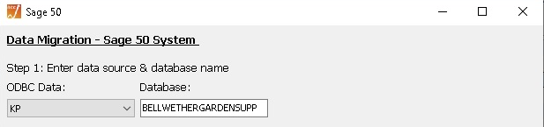

1. Enter the Username & Password as configured in the steps above when setting up **Crystal Reports/Data Access**.

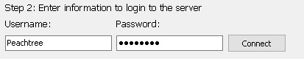

1. Under the modules, Chart of Account should be pre-selected. **Note**: You may tick other modules if you wish to skip.
2. Click Execute and wait for the process to finish.

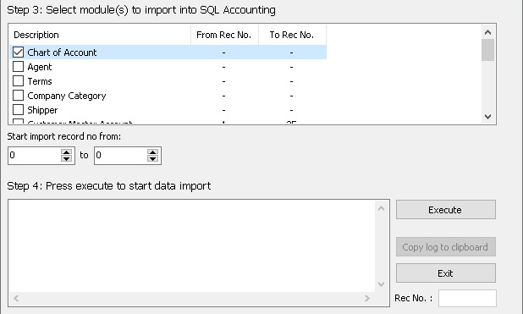

1. After importing **Chart of Account**, close the Sage 50 window and perform the following steps:
   * Select GL > Maintain Account on the main navigation window. Check all accounts are imported & assigned to the correct type.
   * Select GL > Maintain Stock Value on the main navigation window. Click the New button to assign your stock account & value.
   * Select Tools > Options. Once the Options window appears, select General Ledger and assign the default accounts. Do the same for both Customer & Supplier. Click OK.
2. Repeat step 1 to 3.
3. Execute import for other remaining modules in the order of top to bottom.
4. Check all imported data once finished.

**Import Sage 50 Opening Balance to SQL Account**

**Note**: Tested only on Single user/Single computer environments

Preparation steps:

1. Select Tools > Options. Select General Ledger on the Options window.
2. Check if the **Financial Start Period** and **System Conversion Date** is what set correctly.

Execution steps:

1. Repeat step 1 to 3 from **Import Sage 50 Master Data to SQL Account**.
2. Under the modules, select any or all of the opening balance:
   * Opening Customer Invoice
   * Opening Customer Credit Note
   * Opening Customer Payment
   * Opening Supplier Invoice
   * Opening Supplier Credit Note
   * Opening Supplier Payment
3. Click Execute and wait for the process to finish.
4. Check all imported data once finished.