Remote Access Documentation
Remote access will need a third party software like Microsoft Terminal Service, VNC, PC Anyware, or others. With SQL Software, we suggest Microsoft Terminal Service.

Remote access require broadband internet connections (Streamyx). Recommended bandwidth is Streamyx Basic 1.0M and above. Example: Each user on terminal services require a minimal of 128k of bandwidth, hence 384kb bandwidth can maximum cater to 3 users excluding any regular internet usage. Please check your local Streamyx provider for details. 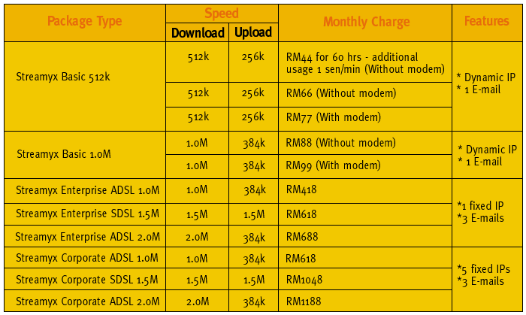

Microsoft 2000/ 2003 SERVER around $2500. Microsoft Terminal Service around $2500 for 5 user license. No need Microsoft Terminal Service license if their PC is Windows XP Professional.

Installation and settings require professional services and charges varies from $800 onwards. Additional services are normally per trip basis.

Watch SQL remote access video go to www.estream.com.my/video. To watch the video, you will need to download the video player, install the player http://www.estream.com.my/video/Webex Player.exe (2.2mb) and go to our video folder and download http://www.estream.com.my/video/Remote_Acess (2.5mb) Please switch your screen resolution to 1024 x 736 before viewing.

Once you have run Remote Desktop Connection
PC no 1 :- estream.homelinux.com:16868
PC no 2 :estream.homelinux.com:17878

User Name : sql
Password : sql

Only one login to one PC at a time. We have 2 PC for testing.

