Step by Step : SQL Account or Payroll – Network Setting

Server PC Setting

Session 1 : Install Firebird Version
Visit http://www.sql.com.my/support/downloads to download firebird version.
1.1 Install Firebird 2.5 version or higher. If Window System Type is 64 Bits, please download Firebird 2.5 64 Bits
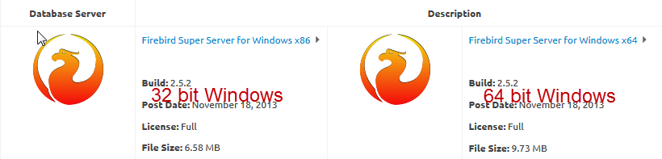
1.2 Run Firebird setup | Press Ok | Click Next | Select I accept the agreement | Click 3 times Next | Make sure it is Super Server binary (Refer Pic1) | Next | Next |
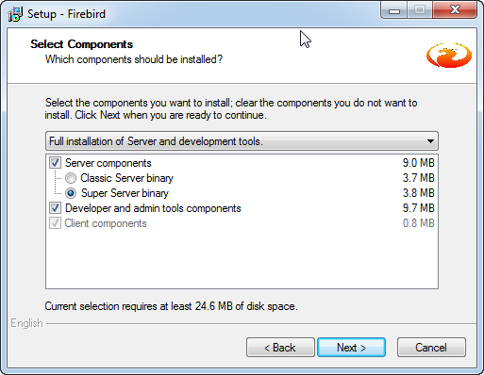Pic 1
* Tick Use Classic Server binary ONLY IF SERVER HAVE MORE THAN 16GB RAM (Refer Pic2) | Next | Install | Next | Finished | Done
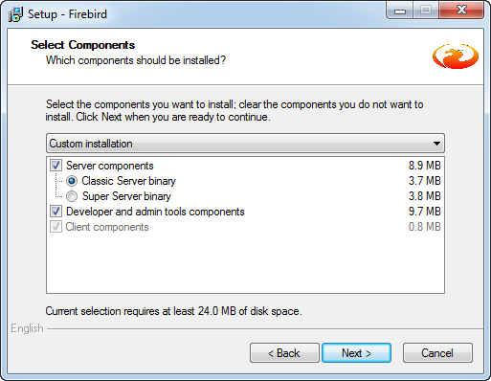Pic 2

Session 2 : Window Firewall
2.1 Control Panel | Window Firewall | Advanced Settings | Inbound Rules | New Rules |
2.2 Select Port | Next | TCP | Specific Local Port = 3050 | Next | Next | Next |
2.3 Name = Firebird | Finish

Session 3 : Network and Sharing Center
3.1 Control Panel | Network and Sharing Center | Change Advanced sharing Settings |
3.2 Network Discovery
- turn on Network Discovery
File and Printer Sharing
- Turn on sharing so anyone with network access can read and write files in the public folders
Public Folder Sharing
- Turn on Sharing so anyone with network access can read and write files in the Public folders
File Sharing Connection
- Use 128-bit encryption to help protect file sharing connections(recommended)
Password protected Sharing
- Turn off password protected Sharing

Session 4 : Share the SQL Account or Payroll Folder
4.1 My Computer | Go to C:\eStream\SQLAccounting\Share or Go to C:\eStream\SQL Payroll\Share | Right Click | Properties | Sharing Tab | Advanced Sharing | Tick Share this Folder | Click Permissions | Tick Full Control | Press OK | Ok |
4.2 Click on Security Tab | Click Advanced | Click on Change Permissions | Click Add Button | At empty Box enter : Everyone | Press OK | Tick Allow Full Control | Press OK | OK | OK | OK

Session 5 : Install SQL Account or Payroll
5.1 Run SQL Account or Payroll Setup | Click Next | Choose I Select the Agreement | Click Next |
5.2 Amend to C:\eStream\SQLAccounting or C:\eStream\SQL Payroll | Click Next | 3 times | Install | Click Finish
5.3 Create Group | Click DCF Group | Click save Button
5.4 Database Engine = Firebird Server | Click Test Connection. If the status shown in blue color, press OK (Refer Pic3) 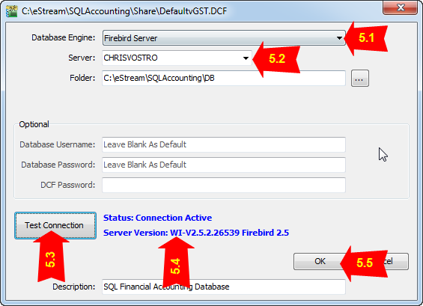Pic 3
- Please take note of antivirus program. Have to add exception at Firewall

Session 6 : Client PC Setting
6.1 Run SQL Account or Payroll Setup | Click Next | Choose I Select the Agreement | Click Next 4 times | Install | Click Finish
6.2 Add Group | Click DCF File
6.3 Select Share folder (At Session 4)| Select Default DCF
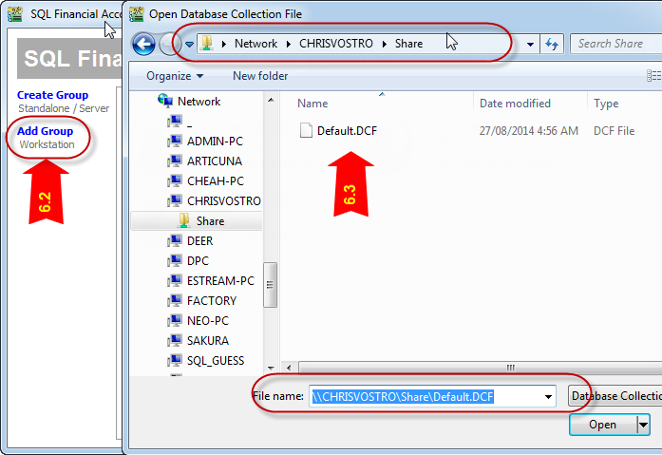
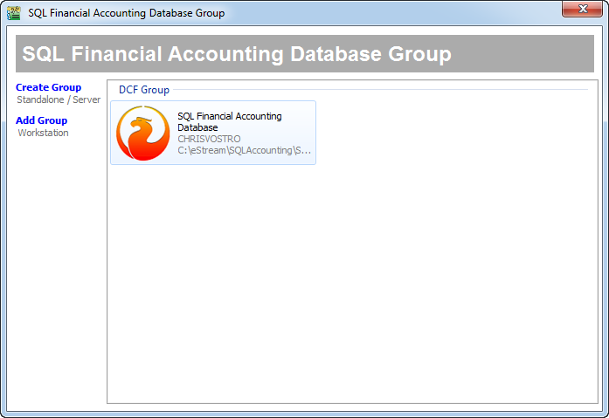
6.4 Click on Firebird icon and Logon as usual.

